**Exercise 3**

**Collaborator Documentation**

All of the other members of the group should then be added as collaborators, so they can commit to the repository also.

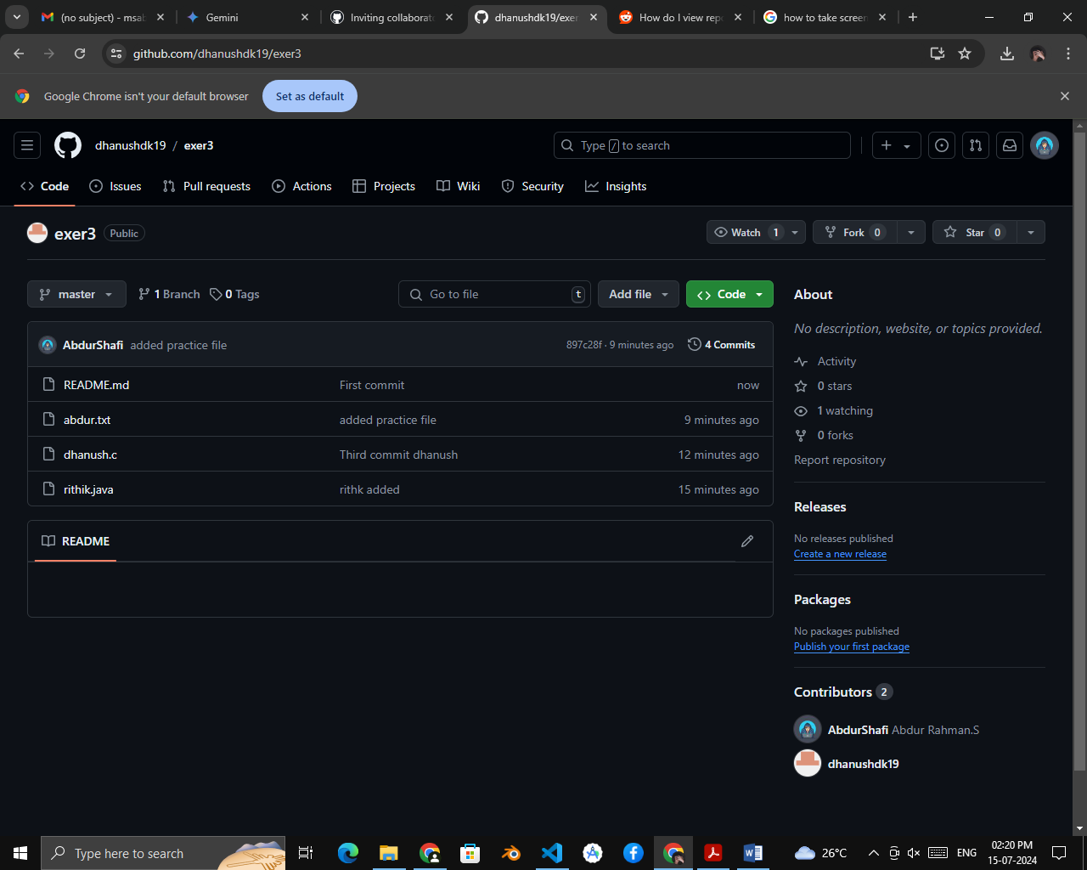

Next, everyone else in the group should **clone** the repository from GitHub. Verify that the context of the repository is what is expected.

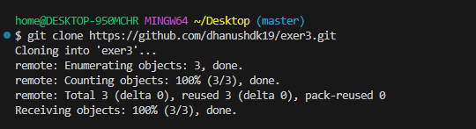

One of the group members who just cloned should now make a local **commit**, then **push** it. Everyone should verify that when they **pull**, that commit is added to their local repository

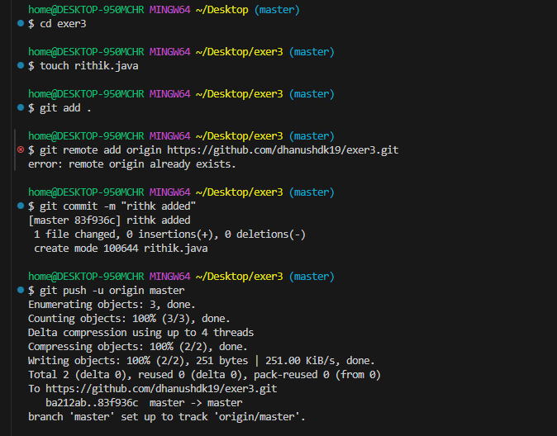

use **git log** to check for it .Look at each other’s **git log** output

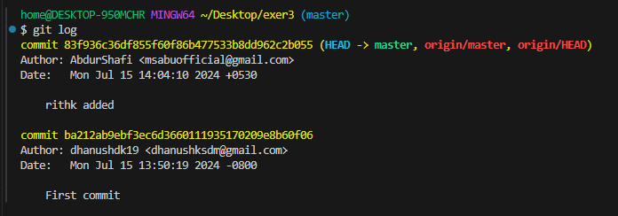

Two members of the group should now make a **commit** locally, and race to **push** it. To keep things simple, be sure to edit different files.

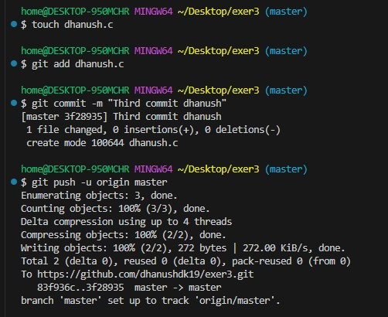

The runner-up should now **pull**. As a group, look at the output of the command. Additionally, look at the **git log**,

***I am Not the Runner Up I am the Winner***

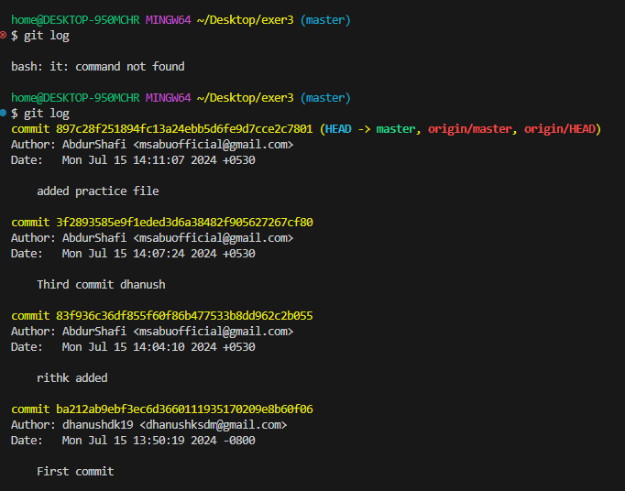

You may also wish to view the DAG in **gitk.**

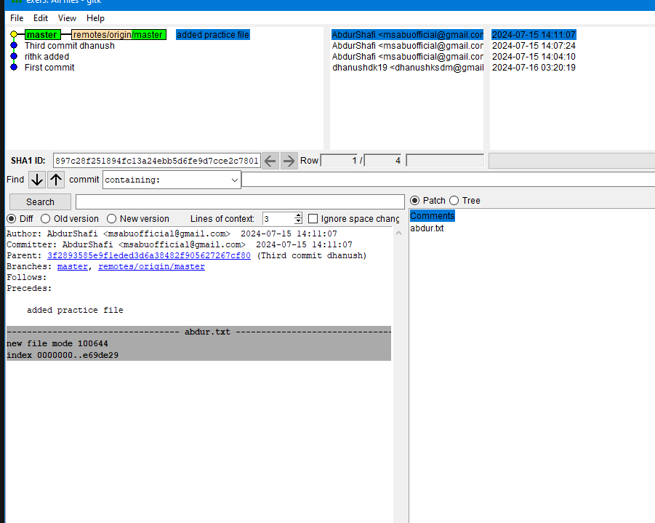

Repeat the last two steps a couple of times, to practice.



